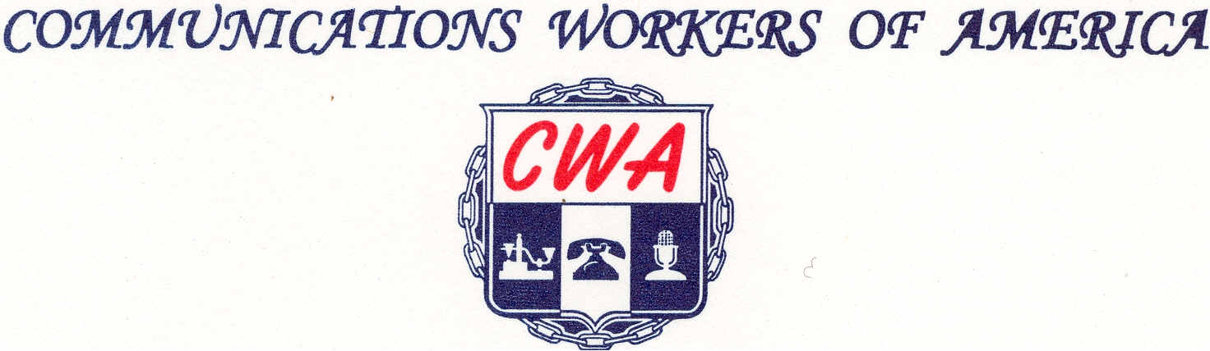
LOCAL 6372
MISSOURI / KANSAS
(Affiliated with AFL-ClO)

May 27, 20201
RE: 2021 Contract Ratification Vote
To All CWA Local 6372 Members
CWA Local 6372 E Board would like to advise everyone that the 2021 Contract Ratification Vote Count was as follows.
Number of Eligible Voters and Ballots Mailed-78
Number of Ballots Received-63
Number of YES Ballots for Ratification- 50
Number of NO Ballots for Ratification- 12
Number of Spoiled Ballots- 1
With the above information, if you have any more question, please contact me directly.
Sincerely,
Russell Bollinger
President
CWA Local 6372



