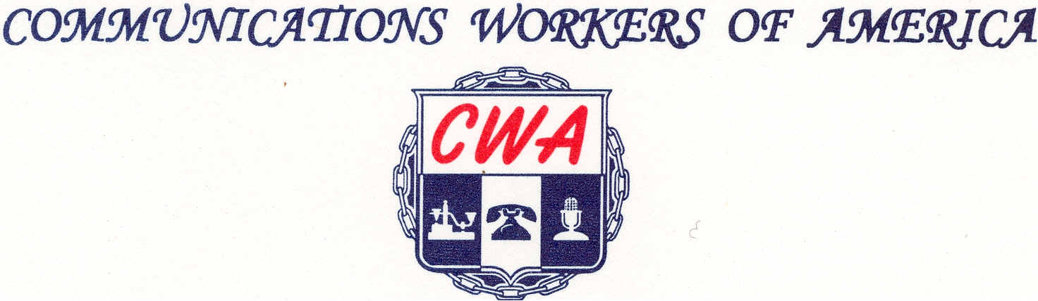
LOCAL 6372
MISSOURI / KANSAS
(Affiliated with AFL-ClO)



